**Report on Ex0**

|  |  |
| --- | --- |
| **201508231** | **Nimrod Godinger** |
| **203203229** | **Israel Haiman** |

**General information**

Our code working at the following order:

- Getting a CSV file from WiGLE WiFi application.

- Analyze the information and sorting the ten strongest signals.

- Sorting the info by the user preference (All Data/ Time/ ID/ Coordinates).

- Creating a KML file with all the data the user asked for.

**Functions:**

1. First, we want function that could write new file.

We pulled the information we got from the WiGLE WiFi application.

Then we used "RandomAccessFile" function which is at Java.io.

After that, we used the open code javacsv.jar to write a new CSV file, the following link is where we have downloaded the code:

<https://sourceforge.net/projects/javacsv/files/JavaCsv/JavaCsv%202.1/> .

Finally, we created a CSV file with all the information above.

2. The assignment continues with function that creates KML File:

We used an ArrayList as our data structure that receiving a String type, then we took code form open source to convert XML to KML from the URL: <http://schemas.opengis.net/kml/2.2.0/ogckml22.xsd> .

Next, we gave the user four information-sorting options by:

All Data / Time / ID / Coordinates.

Now, we created a new ArryList that organized by the following order:

A. Used the open source (as you can see above).

B. The sorted-information followed by the user selection.

C. Defined the file type as KML.

After we gather all the information for one Wi-Fi station, we will move to the next in line and continue to the next station in line and so on, till the last Wi-Fi station at the ArryList.

**Tools We Used**

1. javacsv.jar. Link: <https://sourceforge.net/projects/javacsv/>

2. giscore-2.0.0 . Link: <http://www.java2s.com/Code/Jar/g/Downloadgiscore200jar.htm>

**Experiment details**

1. Getting the CSV information from WiGLE WiFi application:

- Wi-Fi signals from the application.

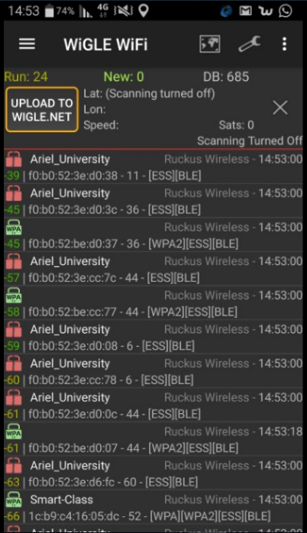

* Exporting the data as CSV file from the application.

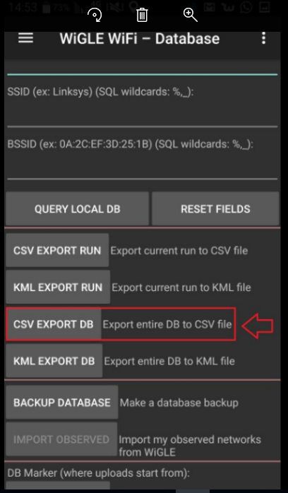

* The data downloaded as Excel file.

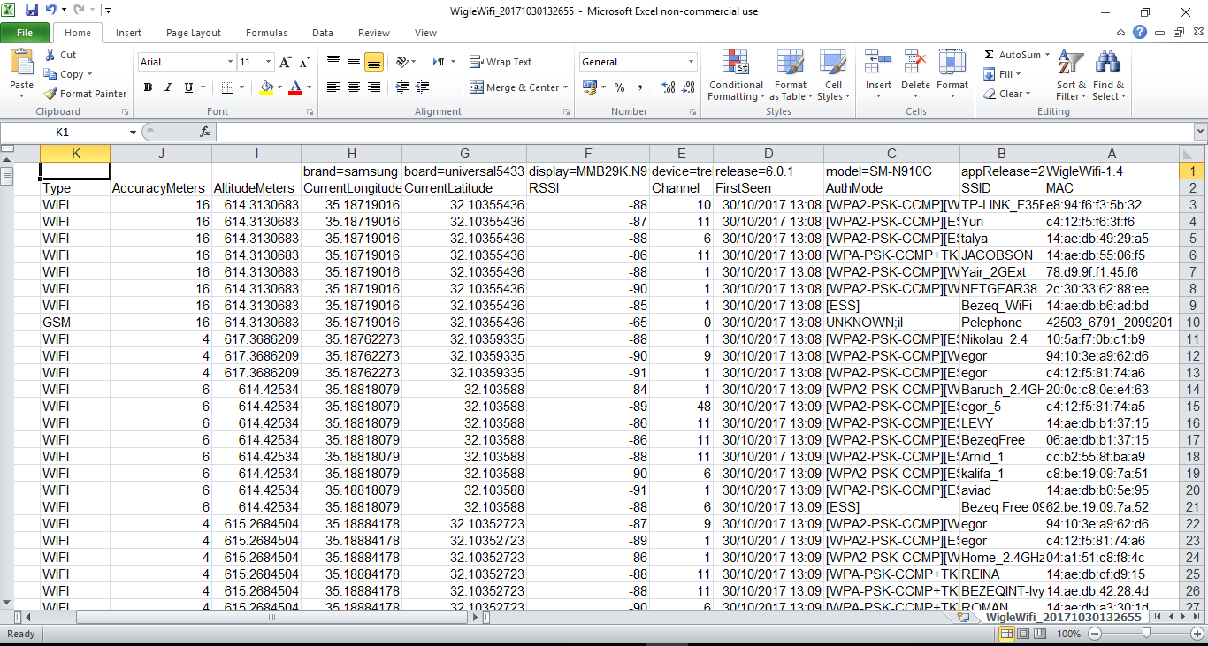

* 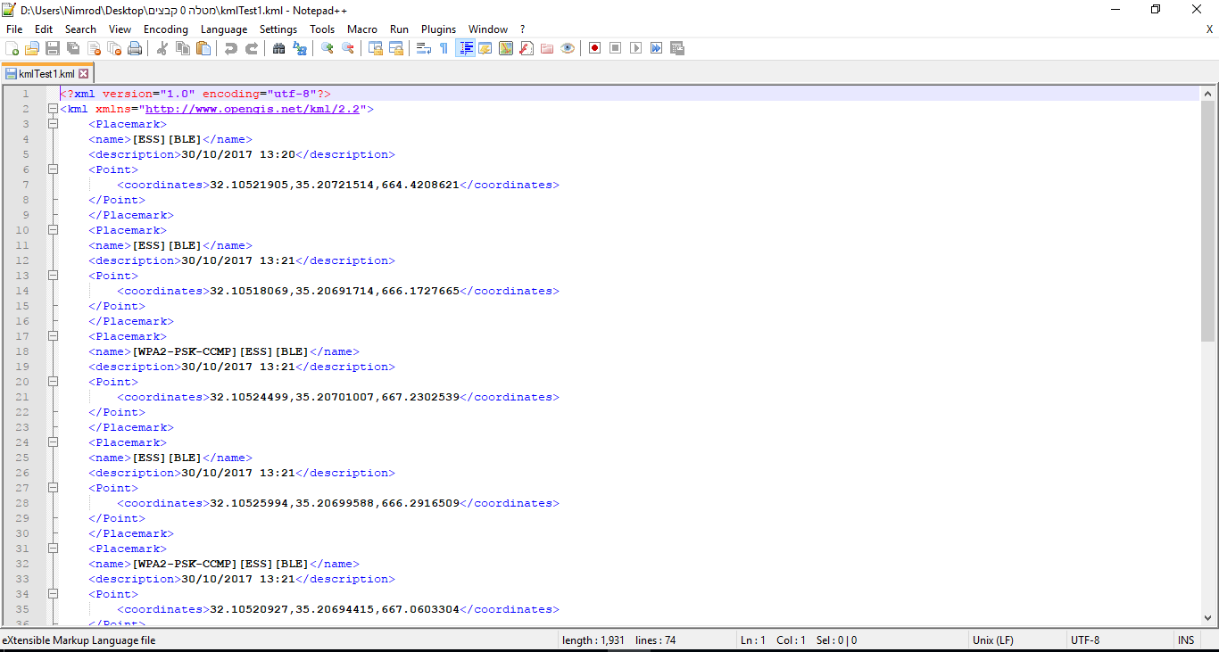The data is sorted and the CSV file convert to KML file.
* Unfortunately, we have also had some problems on the way. For example, when we tried to upload the KML file to Google Earth, we received the following error.

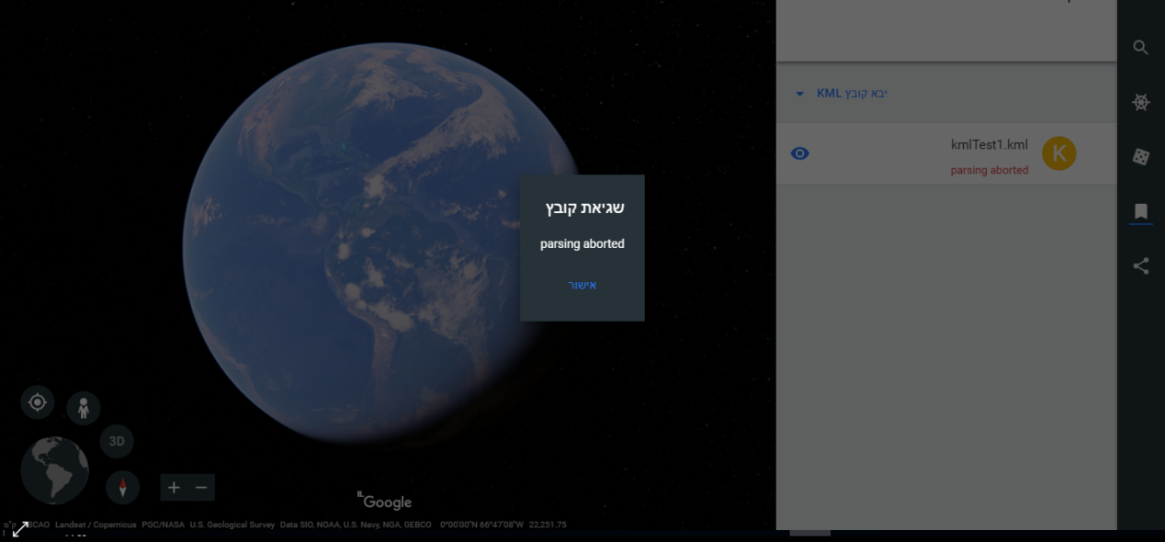

* We have also tried to see the location on Google Maps, to see if the coordinates are at the on the same spot as the Wi-Fi signals, but we have discover that the location is at the Middle-Eastestern Sea.

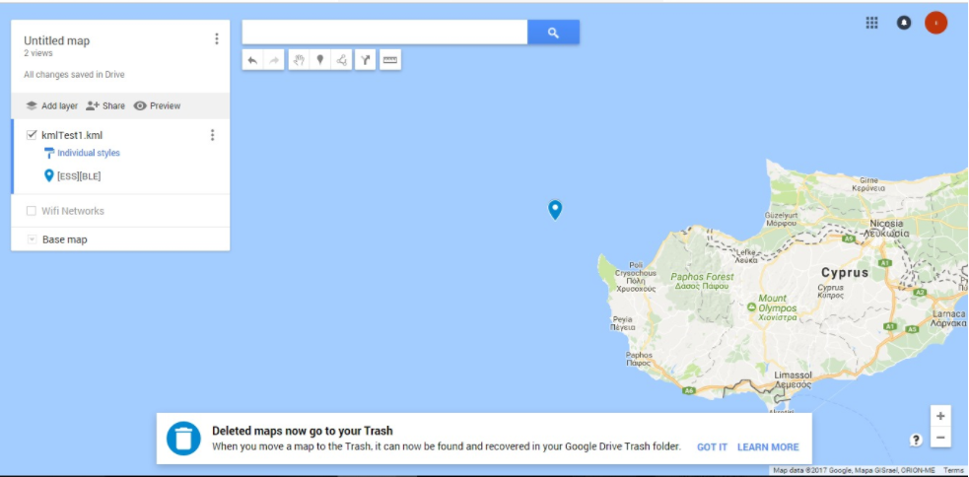

* So, after lots of Debugging we have figured the problem at our code - We have fixed the problem.

